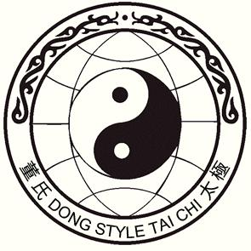
Tai Chi Chuan

3-Day Camp Intensive in New York’s Hudson Valley

with 4th Generation Master

Alex Dong

Nov. 3rd to 5th, 2017
Lifebridge Sanctuary, Rosendale New York
(about 90 miles north of New York City)

Cost for the 3 day camp, $475, includes:

2 nights lodging, shared rooms and bath

Students must
know the whole
Slow Set to attend
the whole
weekend camp.

Bed linens, towels & liquid soap are provided, but not shampoo
7 classes: Friday 3:00 pm & 7:00 pm
Saturday - 10:00 am, 3:00 pm & 7:00 pm
Sunday – 10:00 am and 2:00 pm

Classes will include a mixture of forms and Qigong

Commuter option: $395, includes:
All classes, meals and facility charge (no lodging)

Register by Sept. 30

After Oct. 1, add 10%

10-20% charge
for cancellations

No Refund after Oct. 25.

Saturday only options:
Morning and afternoon class with lunch
$110 (1st and 2nd section of Slow Set)
Morning class with lunch
$65 (1st section and fundamentals)
Price includes a facility charge from Lifebridge

Send payment to Martha Cheo,

115 Springtown Rd., New Paltz, NY 12561

845-256-9316, mcheo@hvc.rr.com

(checks payable to Martha Cheo) OR PayPal (friends & family) to mcheo@hvc.rr.com

Please register me for Alex Dong’s Hudson Valley Intensive, November 3-5, 2017

Name________________________________________ Phone_________________________

Address______________________________________ City_________________________

State________ Zip__________________ Email_____________________________________

